***The Battle of Neighborhoods***

***Find the best location for opening a restaurant***

In order to use the resources of Foursquare, I propose to simulate a search for the best location for opening the restaurant in New York City.

**Introduction**

Manhattan has been described as the cultural, financial, [media](https://en.wikipedia.org/wiki/Media_(communication)), and [entertainment](https://en.wikipedia.org/wiki/Show_business) capital of the world, and the borough hosts the [United Nations Headquarters](https://en.wikipedia.org/wiki/United_Nations_Headquarters). Anchored by [Wall Street](https://en.wikipedia.org/wiki/Wall_Street) in the [Financial District](https://en.wikipedia.org/wiki/Financial_District,_Manhattan) of [Lower Manhattan](https://en.wikipedia.org/wiki/Lower_Manhattan), New York City has been called both the most economically powerful city and the leading financial center of the world.

Many districts and landmarks in Manhattan are well known, as New York City received a record 62.8 million tourists in 2017, and Manhattan hosts three of the world's 10 most-visited tourist attractions in 2013: [Times Square](https://en.wikipedia.org/wiki/Times_Square), [Central Park](https://en.wikipedia.org/wiki/Central_Park), and [Grand Central Terminal](https://en.wikipedia.org/wiki/Grand_Central_Terminal).

What economic impacts does tourism have?

Tourism has a variety of economic impacts. Tourists contribute to sales, profits, jobs, tax revenues, and income in an area. The most direct effects occur within the primary tourism sectors -lodging, restaurants, transportation, amusements, and retail trade. Through secondary effects, tourism affects most sectors of the economy. An economic impact analysis of tourism activity normally focuses on changes in sales, income, and employment in a region resulting from tourism activity. A simple tourism impact scenario illustrates. Let’s say a region attracts an additional 100 tourists, each spending $100 per day. That’s $10,000 in new spending per day in the area. If sustained over a 100 day season, the region would accumulate a million dollars in new sales. The million dollars in spending would be distributed to lodging, restaurant, amusement and retail trade sectors in proportion to how the visitor spends the $100. Perhaps 30% of the million dollars would leak out of the region immediately to cover the costs of goods purchased by tourists that are not made in the local area (only the retail margins for such items should normally be included as direct sales effects). The remaining $700,000 in direct sales might yield $350,000 in income within tourism industries and support 20 direct tourism jobs. Tourism industries are labor and income intensive, translating a high proportion of sales into income and corresponding jobs.

**Times Square**

  Times square is a major commercial intersection, tourist destination, entertainment center and neighborhood in the [Midtown Manhattan](https://en.wikipedia.org/wiki/Midtown_Manhattan) section of [New York City](https://en.wikipedia.org/wiki/New_York_City).

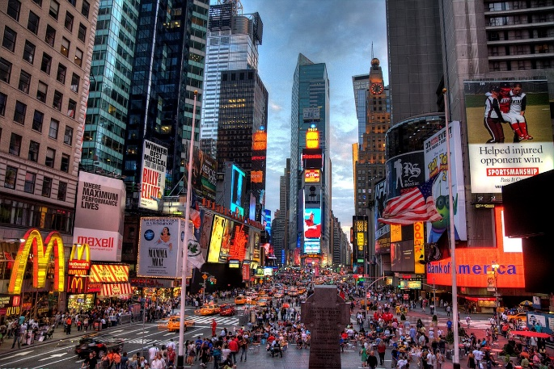Times Square is sometimes referred to as "The Crossroads of the World.  "The Center of the Universe, the heart of [The Great White Way](https://en.wikipedia.org/wiki/The_Great_White_Way) , and the "heart of the world”. One of the world's busiest pedestrian areas, it is also the hub of the [Broadway](https://en.wikipedia.org/wiki/Broadway_theatre) [Theater District](https://en.wikipedia.org/wiki/Theater_District,_Manhattan)and a major center of the world's [entertainment industry](https://en.wikipedia.org/wiki/Entertainment_industry). Times Square is one of the world's most visited tourist attractions, drawing an estimated 50 million visitors annually. Approximately 330,000 people pass through Times Square daily, many of them tourists, while over 460,000 pedestrians walk through Times Square on its busiest days.

Times Square is the most visited place globally with 360,000 pedestrian visitors a day, amounting to over 131 million a year. As of 2013, it had a greater attendance than do each of the [Disney theme parks](https://en.wikipedia.org/wiki/Disney_theme_parks) worldwide, with 128,794,000 visitors between March 2012 and February 2013, versus 126,479,000 for the [Walt Disney World](https://en.wikipedia.org/wiki/Walt_Disney_World) theme parks in [Bay Lake, Florida](https://en.wikipedia.org/wiki/Bay_Lake,_Florida), in 2012.

Even excluding residents from the visitor count, Times Square is the world's second most visited tourist attraction, behind the [Las Vegas Strip](https://en.wikipedia.org/wiki/Las_Vegas_Strip) .The high level of pedestrian traffic has resulted in $4.8 billion in annual retail, entertainment and hotel sales, with 22 cents out of every dollar spent by visitors in New York City being spent within Times Square.

**Manhattan Cultural Tourism Grant**

https://www.manhattanbp.nyc.gov/includes/site_images/misc/spacer.gif

**About the Grant**

Each year, New York City & Company Foundation funds and administers the Manhattan Cultural Tourism Grant – designed to support cultural-tourism marketing and audience-development initiatives that will expand awareness of the various neighborhoods throughout the borough of Manhattan.

Working in partnership with Manhattan Borough President Gale A. Brewer, the Foundation grants funds to support nonprofit arts and cultural organizations identified by the Borough President. These projects must be consistent with the Foundation’s mission to support cultural tourism and educate audiences about the range of cultural opportunities that the borough of Manhattan has to offer.

**NYC & Company Foundation Mission**

The NYC & Company Foundation is a 501(c)(3) charitable and educational organization whose mission is to support tourism to New York City by promoting the arts and cultural organizations that make visiting New York a special and exciting experience. Since its inception in 1999, the Foundation has created and implemented a range of audience development and outreach projects to educate domestic and international visitors about the vibrant cultural community throughout all five boroughs.

### 1. Problem to be resolved:

The challenge to resolve is being able to find the location for opening a restaurant that acquirable to profit in Manhattan NYC . Therefore, in order to set a basis for comparison, I want to find a location unit subject to the following conditions:

* Location close to Times square that has most visited tourist attractions.
* Area that close to the recreational places that tourism grant facilities.

### 2 .How the data will be used to solve the problem.

The data will be used as follows:

Use Foursquare and geopy data to map top 10 venues for all Manhattan neighborhoods and clustered in groups (as per Course LAB) Use foursquare and geopy data to map the location of Times Square Entertainment Venues , separately and on top of the above clustered map in order to be able to identify the venues and amenities near each areas, with explore Using Foursquare. create a map that depicts the Tourism Grants organization near by Times square in Manhattan area . I will be able to quickly point to the popups to know the relative. Addresses and locations will be converted to geodata( lat, long) using Geopy-distance and Nominatim.

3. Data

The data acquired form Data.gov website and type of the file that choses is csv file because it is easier to manipulation and reading. Both files uploaded to my Github references. link to the files are:

* <https://catalog.data.gov/dataset/tourism-grants-17668>
* <https://catalog.data.gov/dataset/times-square-entertainment-venues-c8ebb>

3. Methodology section:

This section represents the main component of the report where the data is gathered, prepared for analysis. The tools described are used here and the Notebook cells indicates the execution of steps.

The analysis and the strategy:

The strategy is based on mapping the above described data in section 2.0, in order to facilitate the choice of at least two candidate places for opening the restaurant. The choice is made based on the demands imposed :

location near a Times square, New York. This visual approach and maps with popups labels allow quick identification of location, feature to making the selection very easy.

The processing of these DATA and its mapping will allow to answer the key questions to make a decision:

1. What are the top 5 common venues in Manhattan?
2. How venues distribute among Manhattan neighborhoods and around Times square?
3. How much is the Amount Request for allocation of tourism facilities?
4. Where is the location of the organization?

5.Result:

After examining, I have chosen two locations these locations is good to start a restaurant because they're so close to times square and theaters

location 1:Midtown South ,Cluster # 2

location 2:Clinton ,Cluster #1

**Thank You!**